Advanced Games Programming
Tutorial 06 - Drawing Complex Scenes using a Z buffer

Introduction

In the previous tutorial you created and set up transformation matrices in order to move objects in a 3D world space, and then to correctly project them onto a 2D surface, allowing you to view the objects at their perspective correct positions in the 3D world on-screen. In this tutorial you will learn how to render several objects in a more complex scene taking into account their depth correctly using a Z buffer.

Rendering Complex Scenes

So far you have been rendering a single very simple object, either a single triangle or a primitive shape. As your 3D scenes become more complicated with more objects you will find that parts of one object will be drawn over another. This can cause problems if one object is further away in 3d space than another. For instance, in this example the cube that appears in front is not smaller and closer than the other cube, it is in fact the same size but further away.

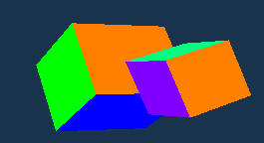

The reason why it appears in front is that the closer, larger appearing cube is drawn first, and the further away one is drawn second. Obviously this is not ideal in a 3D world, it would make more sense if objects further away were obscured by closer ones. One way you might think of solving this would be to draw the furthest away objects first. This would partially solve the problem, but unfortunately it still doesn't completely solve the problem as when you start using complex objects it is impossible to find a correct ordering for all orientations that you might view an object, or set of objects. For instance, there is no way to draw these overlapping triangles just by ordering drawing:

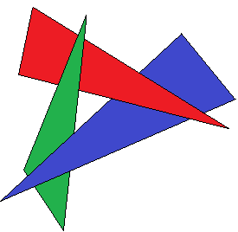

The Z buffer

Fortunately modern graphics hardware provides a simple solution to this problem, using a process called Z buffering (or depth buffering). Essentially this process stores a Z value of each pixel drawn into a Z buffer (or depth buffer). The Z value in the Z buffer represents a distance from the projection plane. This buffer is another buffer in addition to the buffers in the swap chain, with the same dimensions so there can be a z value for each pixel on screen. Every time a pixel is about to be drawn, the hardware calculates its z value and checks to see if it is nearer than the last pixel drawn to that point on screen, and only then will it allow it to be drawn and the Z buffer will be updated with the new z value. If the pixel is further than the existing pixel then it is not written to. With a Z buffer initialised and enabled the previous scene can be rendered correctly e.g.:

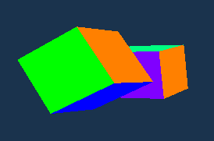

Z Buffer Accuracy

An often misunderstood feature of z buffers is the way the z value is stored, and how the near clipping plane value can dramatically affect how the z buffer performs. In the last tutorial you used a function to create a projection matrix using near and far clipping plane values to indicate where objects should be clipped. In Direct3D these values are also used to determine the range of the z buffer. The z value is a floating point value between 0.0 and 1.0, nearest and furthest distance respectively. However, the z value is not linearly (evenly) distributed between the near and far clipping planes, but is instead exponentially weighted towards the near plane based on the values of the clipping planes. In essence most of the accuracy is concentrated nearer the viewer, where usually you would prefer the highest precision as this is the area most likely noticed by the viewer.

The following diagram approximates the distribution of z values, with black representing 0.0 and white 1.0:
NEAR PLANE
FAR PLANE
MID DISTANCE

As you can see, most of the range of the z buffer is concentrated near the viewer. Usually this is fine, but can cause problems for situations where distant object interactions are required, such as in space combat games. Additionally the fact that the distribution is strongly affected by the near clip plane is often missed. The smaller the near clip value is, the more the accuracy is concentrated nearer the viewer, so for too small a value the range will not be effective. For instance you might think reducing the near clip plane to 0.00001 might be a good idea to stop clipping from taking place as the camera moves close to objects. However this means most of the z range will be extremely close to the camera, and an effect called z fighting will occur. This can look something like this:

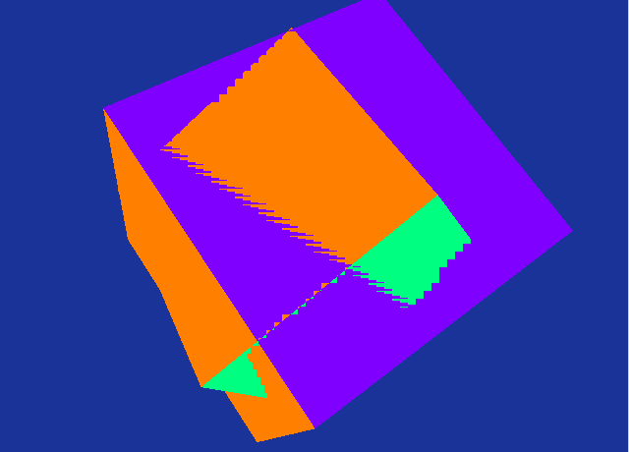

There are work arounds for these situations, but these are beyond the remit of this unit. For now just be aware that very small clip plane distances can cause problems when using z buffers.

Exercise 01a - Creating a cube and drawing it several times

- Create a new project based on your Tutorial 05 Exercise 03 project (or one of the extra/advanced exercises), renaming it in the correct way.
- Change your vertices array to represent a cube. Each face consists of two triangles, here are the x, y and z coordinates (with the correct winding for backface culling) to help you:
// back face
(-1.0f, 1.0f, 1.0f)
(-1.0f, -1.0f, 1.0f )
(1.0f, 1.0f, 1.0f)
(1.0f, 1.0f, 1.0f)
(-1.0f, -1.0f, 1.0f )
(1.0f, -1.0f, 1.0f)

// front face
(-1.0f, -1.0f, -1.0f )
(-1.0f, 1.0f, -1.0f)
(1.0f, 1.0f, -1.0f)
(-1.0f, -1.0f, -1.0f)
(1.0f, 1.0f, -1.0f)
(1.0f, -1.0f, -1.0f)

// left face
(-1.0f, -1.0f, -1.0f )
(-1.0f, -1.0f, 1.0f)
(-1.0f, 1.0f, -1.0f)
(-1.0f, -1.0f, 1.0f )
(-1.0f, 1.0f, 1.0f)
(-1.0f, 1.0f, -1.0f)

// right face
(1.0f, -1.0f, 1.0f),
(1.0f, -1.0f, -1.0f )
(1.0f, 1.0f, -1.0f)
(1.0f, 1.0f, 1.0f)
(1.0f, -1.0f, 1.0f )
(1.0f, 1.0f, -1.0f)

// bottom face
(1.0f, -1.0f, -1.0f )
(1.0f, -1.0f, 1.0f)
(-1.0f, -1.0f, -1.0f)
(1.0f, -1.0f, 1.0f )
(-1.0f, -1.0f, 1.0f)
(-1.0f, -1.0f, -1.0f)

// top face
(1.0f, 1.0f, 1.0f)
(1.0f, 1.0f, -1.0f )
(-1.0f, 1.0f, -1.0f)
(-1.0f, 1.0f, 1.0f)
(1.0f, 1.0f, 1.0f )
(-1.0f, 1.0f, -1.0f)

(if you already have a well formed 3D shape, and/or are using index buffers please feel free to use those instead.
- Give each face of the cube a different colour.
- You will need to update the vertex buffer creation size, use the sizeof() function for convenience instead of manually updating with the number of vertices:
- Change the Draw() function to draw 36 vertices worth of triangles (6 faces x 2 triangles x 3 vertices):
(This will differ if you are using a different object, or index buffers)
- Use the existing World Matrix code to rotate and move the cube to +15 along the z axis.
- Create a new World matrix that has a different rotation and has the z axis changed by keypresses or mouse. Start it at +10 along the z axis, and +1 along the y axis.
- Using the existing code as reference, after drawing the first cube draw a second cube using the new World matrix. What operations do you have to repeat? Which ones do you not? Justify each decision in your logbook and comments.
- Move the second cube forward and backward along the z axis, noting how it as always drawn in front of the first cube.

Exercise 01b - Creating a Z buffer in Direct3D

- Add the following to the globals section of your code:
- Add this code to the InitialiseD3D() function, immediately before the OMSetRenderTargets() call:
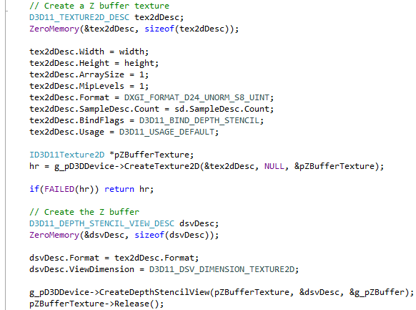

- Change the OMSetRenderTargets() function to set the Z buffer as one of the render targets:

- Add the following code that clears the Z buffer just after ClearRenderTargetView():

this function clears the Z and stencil buffers before any drawing begins, just like clearing the back buffer. The Z buffer is cleared to 1.0f, which if you remember from the viewport setup represents the furthest away value. If this wasn't done the Z information from the previous frame would remain, and rendering would not be correct.
- Finally, don't forget to clear up the global Z buffer pointer before the program exits:
- Move the second cube forward and backward again along the z axis. This time the second cube should disappear behind the first when it is far enough away.
- Add code to rotate the second cube around one or more axes. Move the second cube close in z distance to the first. Notice what happens on a per pixel basis as the cubes intersect. Explain why this wouldn't be possible simply by changing the order of the drawing of the cubes in your logbook.
Some of the previous code will now be analysed in more detail.

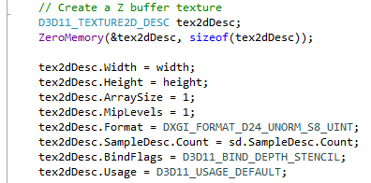

In Direct3D the back and front buffers that are used to display pixels that are drawn are automatically created in the D3D11CreateDeviceAndSwapChain() function, but the z buffer is not. In order to create the Z buffer you need to create a texture object that represents the Z buffer, and this is set up using the D3D11_TEXTURE2D_DESC structure. The Z buffer needs to have the same dimensions and sample count as the back buffer, so the SampleDesc.Count, Width and Height flag are set so accordingly. Don't worry about ArraySize and MipLevels for now, they are for textures that are applied to objects and aren't relevant to Z buffers. The BindFlags flag tells Direct3D that this is a Depth-Stencil texture, i.e. a Z buffer. The stencil part of the texture allows specialised techniques to be used to mask parts of the display, but that is not relevant here. The Format of DXGI_FORMAT_D24_UNORM_S8_UINT tells Direct3D to interpret 24 bits of each pixel for Z depth, and 8 bits for stencilling.

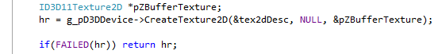

This code uses the tex2dDesc structure to create a Z buffer texture, testing for any failure during creation.

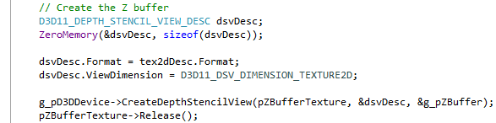

As mentioned before, the Z buffer can consist of both depth and stencil information. When creating the Z buffer from the Z buffer texture you need to tell the creation function CreateDepthStencilView() what format you created the Z buffer texture, so this is just copied from tex2dDesc.Format. The ViewDimension flag simply tells Direct3D to treat this as a 2D texture. Once the Z buffer is created by CreateDepthStencilView() and stored in g_pZBuffer, then the texture can be released as it is no longer needed.

